Hi Professor,
I was working over the 2 directions:
1. online-version
2. single large graph version.
Version -2 seems fine and can be done with only new thing to do is to build the hyper-graph matrices in a new manner.
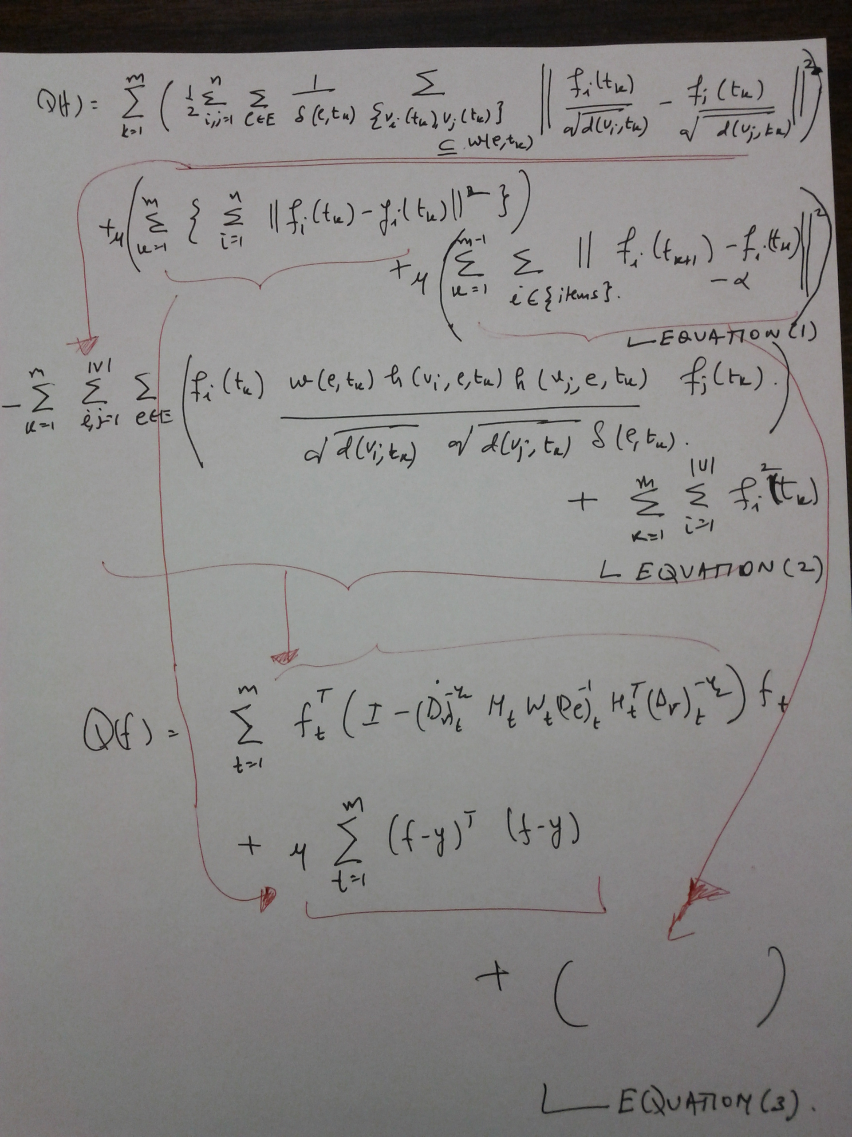
Figure 1
For Version 1 in figure-1 above equation (1) is the objective function to be minimized. Using the similar approach as in our base paper for music recommendation (http://www- scf.usc.edu/~hwu732/paper/ACMMM10_Bu.pdf) in section 3.2 (which is also in thefigure-2 below) we have expanded the first term of equation (1) to a form in equation (2). Finally, the matrix version of the objective function is written in equation (3). Now we are stuck at two things.
- First term of equation (3) still has a summation and the only way to go more concise is to put the equation in Tensor form. Thus, was wondering if there is a method to deal with this situation without going for a tensor approach or do you wish us to go ahead for tensors. If so would you suggest me to do research for papers in this area or is there any specific paper in your mind you might like to suggest.
- Also there is an issue in formulating the third term of equation (3) because the summation in third term of equation (1) runs only for a some specific i values for which ni is a specific (item) type of node. Thus, it not runs for all i=1 to n as it does for second term of equation (1). Thus, how to deal with this issue to get a clean matrix version.
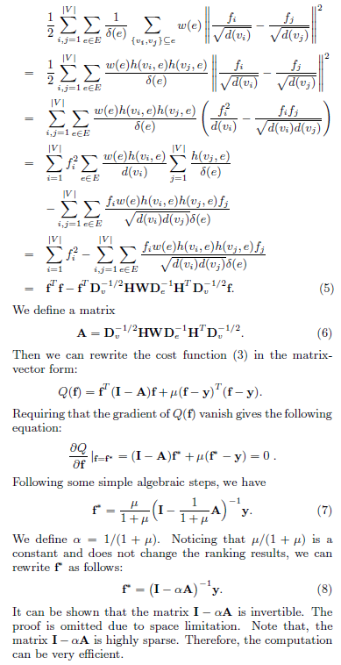
Figure 2

I had gone through your GPL Framework paper and also the NIPS hyper-graph regularization paper.
Firstly one strange doubt that I have is that once you had told that you won't recommend community finding using cut methods as communities in reality always overlap. Given that this NIPS paper builds regularization upon cut method I was a bit skeptic.

